

**FACULTY OF ENGINEERING DESIGN AND TECHNOLOGY**

# GROUP: C QUESTION 3

# 

**COURSE: BACHELOR OF SCIENCE IN COMPUTER SCIENCE (BSCS)**

**COURSE UNIT: CSC 1307 COMPUTER SCIENCE WORKSHOP**

**LECTURER: BACHELOR OF SCIENCE IN COMPUTER SCIENCE (BSCS)**

**LECTURERS: MR. ISAAC NDAWULA & PROF. CHRISTOPHER SSENFUKA.**

TABLE OF CONTENTS

GROUP: C QUESTION 3 1

GROUP THREE MEMBERS: 3

Objective of the project 4

Tools used in the project 4

Features 4

Dimensions of the table 7

PSEUDO CODE FOR THE PROJECT: 7

Circuit diagram: 8

Arduino program code for the project 9

## GROUP THREE MEMBERS:

**NAME ACCESS NO. REG. NO.**

1. **SEKAMATE SOLOMON A96920 J22B23/024**
2. **AYEBARE MOSES A95561 S21B23/032**
3. **MOGA MUZAMIL ABDUL WAHAB A94166 S21B23/013**
4. **TRACY NAJJOBA M. A95681 S21B23/034**
5. **MUKISA ISAIAH A94160 S21B23/007**
6. **NIRINGIYE ALLAN SMITH A97066 J22B23/030**
7. **SENGOBA NABIL A97227 J22B23/035**
8. **KATUKUNDA ROCHELLE A94169 S21B23/016**
9. **KURE PETER A96404 J22B23/008**
10. **MUNJWOK ALALA A98246 M22B23/007**
11. **DAPHINE KAMUSIIME A94405 J22B23/028**
12. **AKAMPA IAN A97756 M22B05/006**

**GROUP C Qn. THREE:** A mobile robot Z to move around edges of the table without **falling using two distance sensors.**

## Objective of the project

Making a robot Z to move around the edges of the table without falling using two distance sensors.

## Tools used in the project

2 ultrasonic sensors

A mobile platform of the robot with 2 servo motors and 2 plastic wheels

A breadboard

Arduino UNO R3

Jumper wires (male to male, male to female and female to female wires)

Power bank

## Features

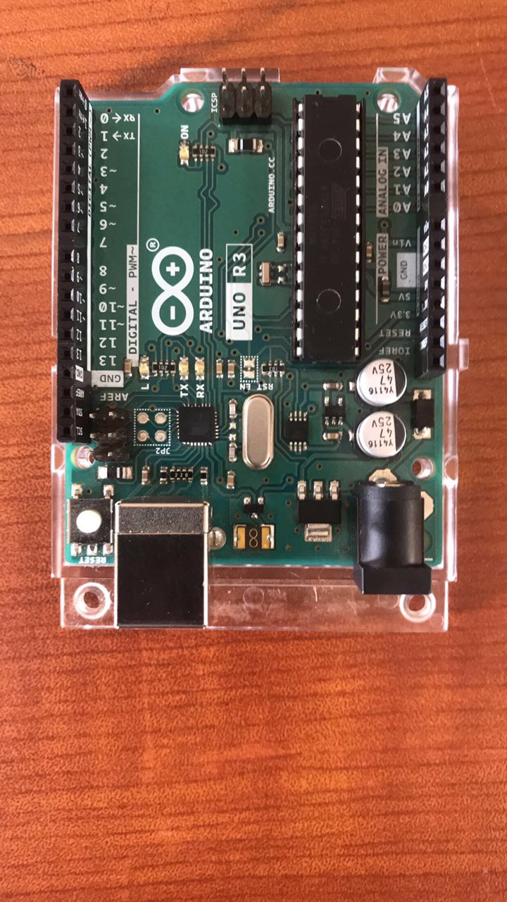 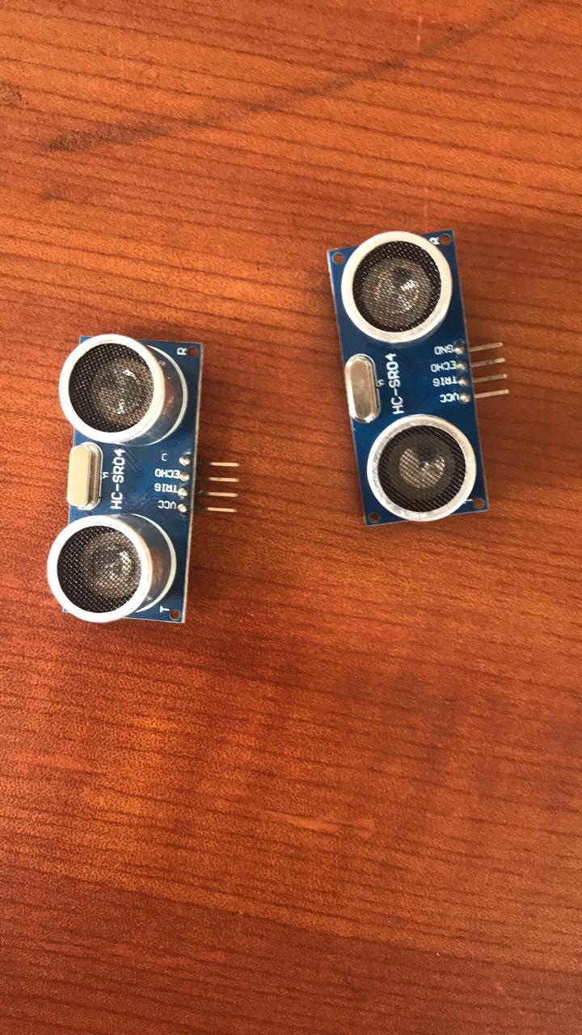ARDUINO UNO R3 2 Ultrasonic sensors(distance sensors)

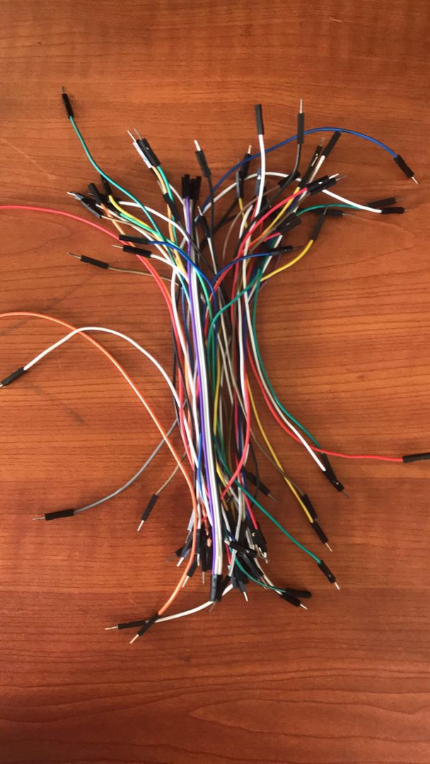 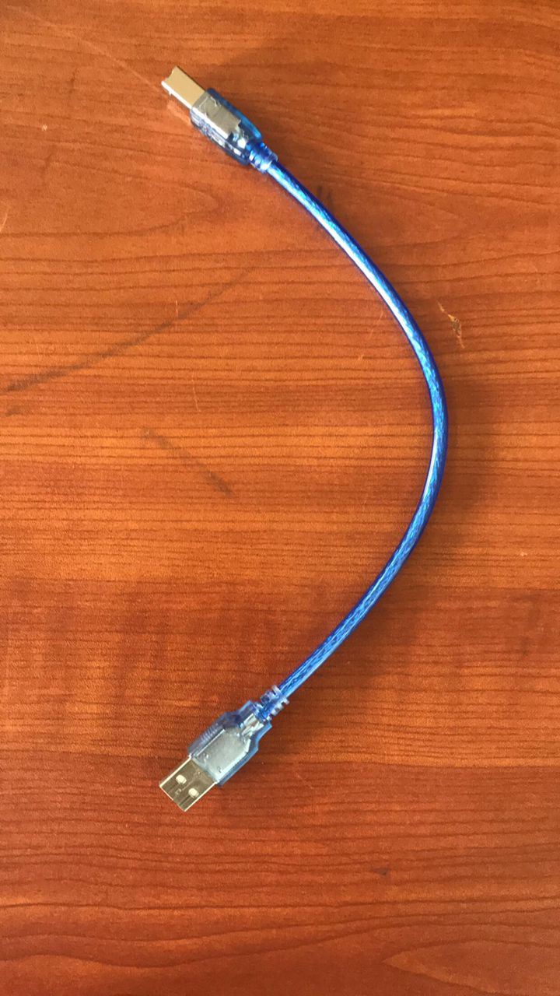

Wire jumpers serial cable

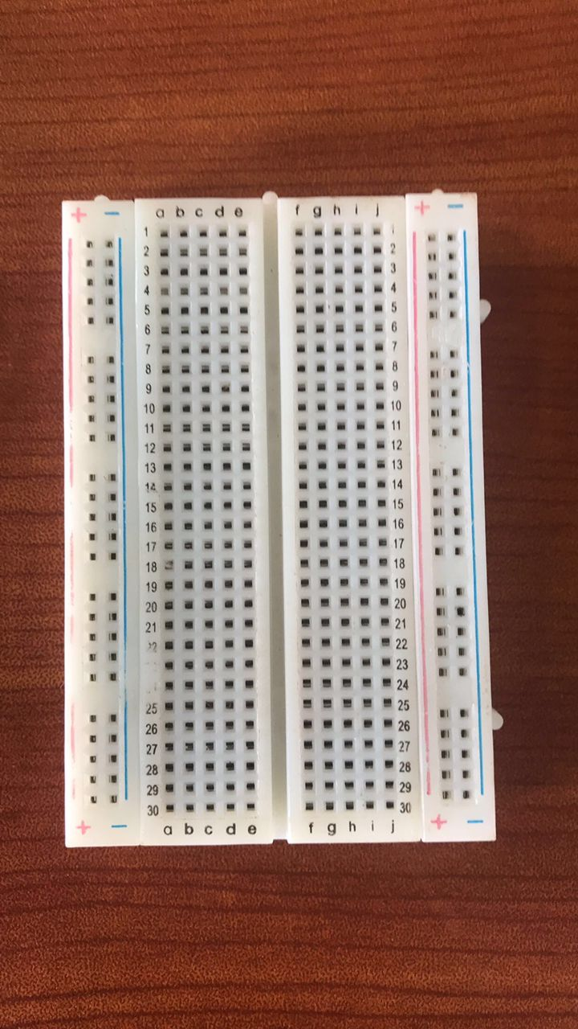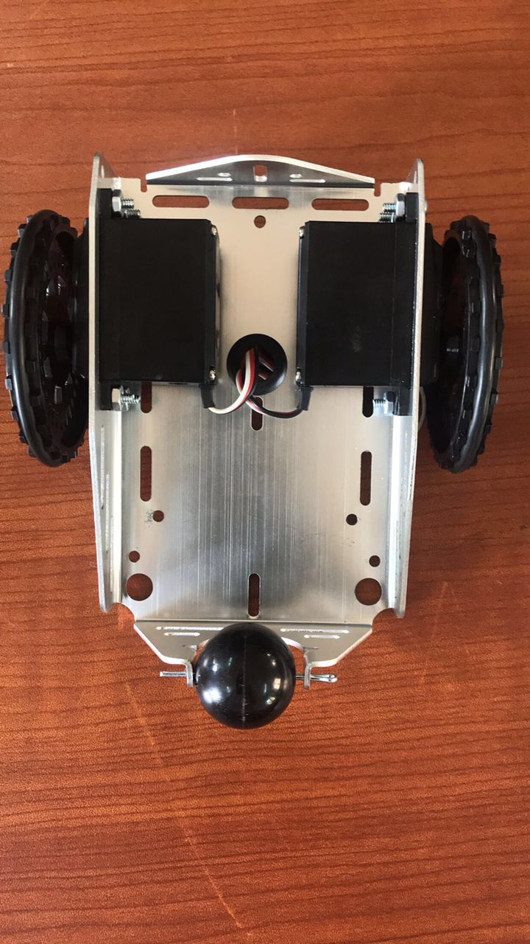

Breadboard A mobile platform of the robot with 2 servo

motors and 2 plastic wheels

 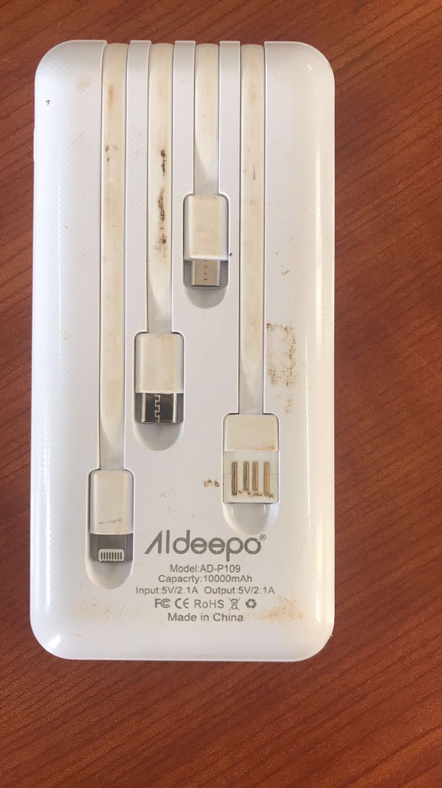

Power bank used power bank used

## Dimensions of the table

Used a table of dimensions 155cm (155000mm) and 61cm (610mm).

## PSEUDO CODE FOR THE PROJECT:

**PSEUDO CODE.**

Import the servo library.

Create two servo objects: servo 1 and servo 2.

Attach the trig pin of sensor 1 to port 9.

Attach the echo pin of sensor 1 to port 10.

Attach the trig pin of sensor 2 to port 5.

Attach the echo pin of sensor 2 to port 4.

Attach the dig pin of servo 1 to port 6.

Attach the dig pin of servo 2 to port 7.

Set trig pin 1 as an output pin.

Set echo pin 1 as an input pin.

Set trig pin 2 as an output pin.

Set echo pin 2 as an input pin.

Set the data rate in bits per second to 9600.

Turn trigger pin on to force out pulse.

Turn it off.

Then turn echo pin on to read pulse and calculate how long it takes to return the pulse.

Use that time to calculate the distance and print it to the serial monitor.

If the distance from sensor 2 is less than 4cm, it’s on the table and if the distance from sensor 2 is greater than 4cm it’s off the table, meaning that the robot should move forward in a straight line.

If the distance from sensor 2 and the distance from sensor 1 are greater than 4cm, the robot should turn to the left, away from the edge.

## Circuit diagram:

­­­­­­­­­­­­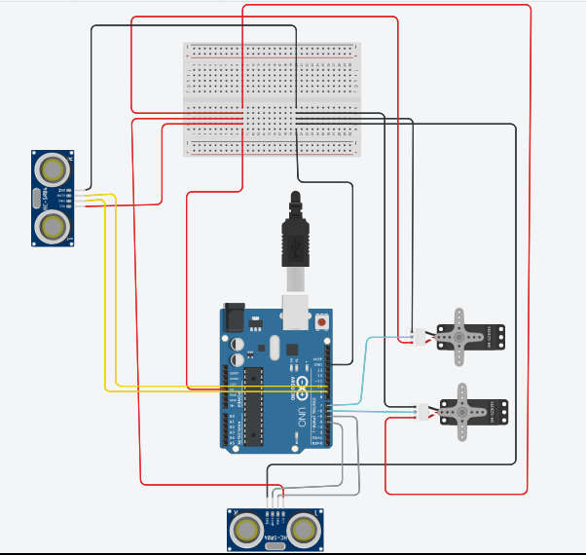

breadboard

Servo 2

Arduino

Sensor 1

Servo 1

Sensor 2

## Arduino program code for the project

#include <Servo.h>

Servo servo1;

Servo servo2;

int TriggerPIN1 = 9;

int EchoPIN1 = 10;

int TriggerPIN2 = 5;

int EchoPIN2 = 4;

void setup(){

  servo1.attach(6);

  servo2.attach(7);

  pinMode(TriggerPIN1,OUTPUT);

  pinMode(EchoPIN2,INPUT);

  pinMode(TriggerPIN2,OUTPUT);

  pinMode(EchoPIN2,INPUT);

  Serial.begin(9600);

  }

void loop(){

  digitalWrite(TriggerPIN1,LOW);

  delayMicroseconds(2);

  digitalWrite(TriggerPIN1,HIGH);

  delayMicroseconds(2);

  digitalWrite(TriggerPIN1,LOW);

  long timedelay = pulseIn(EchoPIN1,HIGH);

  int distance1 = 0.0343 * (timedelay/2);

  Serial.print("Sensor 1 : ");

  Serial.println(distance1);

  delayMicroseconds(2);

  digitalWrite(TriggerPIN2,LOW);

  delayMicroseconds(2);

  digitalWrite(TriggerPIN2,HIGH);

  delayMicroseconds(2);

  digitalWrite(TriggerPIN2,LOW);

  long td = pulseIn(EchoPIN2,HIGH);

  int distance2 = 0.0343 * (td/2);

  Serial.print("Sensor 2 : ");

  Serial.println(distance2);

  if(distance2 > 4 && distance1 > 4){

   servo1.write(70);  //makes the rover turn leftwards

   servo2.write(70);

   delay(500);

    }

  else if (distance2 < 4 && distance1 >4){

    servo1.write(0); //makes the rover move in a continuous straight line

    servo2.write(180);

    }

  }